Reporting Agency: [MINISTRY OF AGRICULTURE CENTRAL REGION]

Country: [ERITREA]

STANDARD PROGRESS REPORT

No. and title: [00063220 SIP-SUSTAINABLE LAND MANAGEMENT PILOT PROJECT…]

Reporting period: [2014]

I. PURPOSE

The proposed project will provide an enabling environment (policy, capacity, knowledge, alternatives) necessary for adoption of sustainable land management practices and alleviate environmental degradation while improving livelihoods of the farming communities of the central highland zone, through four outcomes that overcome the barriers, and are in line with the objectives of the GEF Strategic Investment Program for SLM in Sub-Saharan Africa (SIP) and UNDAF. The first outcome focuses on the development and testing of SLM models in pilot areas; the Serejeka sub-zoba of the Maekel Zoba, one of Eritrea’s major regions. A significant part of the model will be the testing of application of the 1994 Land Proclamation provisions, as an incentive to SLM. Outcome two will support the establishment of sustainable knowledge management systems to provide quality and timely information for decision making, as well as help disseminate lessons, thus directly contributing to the upscaling of the pilot investments. The third outcome is on capacity building, based on a long-term strategy, to establish a critical mass of skilled and empowered SLM actors in Eritrea. The fourth outcome will establish a natural resource management monitoring systems to add an additional layer to upscaling through the systematic documentation of the pilot intervention, lessons learnt and the sharing throughout Eritrea and worldwide.

The main stakeholders in the area of land use and land management in Eritrea are the rural farmers and pastoralists. Rural farmers have a greater role in the cereal/pulse production system of the CHZ while pastoralists are in the lowlands. In addition, a number of national institutions have mandates directly or indirectly affecting land use and land management. They are as listed follows:
Regional (Zoba) Administration
Ministry of Agriculture (MoA)
Ministry of land water and environment)
Ministry of energy and mines
Hamelmalo collage of agriculture
Ministry of Education

II. RESOURCES
The total approved budget to the programme components from core and non-core resources, are:
- GEF 1,820,000 USD
- UNDP 1,000,000 USD
- NORAD 1,000,000 USD
Total 3,820,000USD

III. RESULTS
The main activity in the year 2014 was on Outcome 1: Replicable models of SLM are developed and representative communities use them to manage land in 5 villages of the central highland that are representative of the major agro-ecological zone for Central highlands, reducing the rate of land degradation: Sustainable models for improving agriculture, grazing lands and forested lands developed and piloted in 5villages covering 3,000 ha and a suite of technologies made available. Under this outcome sustainable agriculture, rangeland and woodland management models will be described based on the results of landscape functionality analysis and other cutting edge concepts, and building on traditional management systems and knowledge. Local authorities will be facilitated to use the results of the assessments to undertake a participatory zoning of the common lands into appropriate forms such as sustainable use, protection, restoration, grazing, mixed use, etc. and they have already set management objectives and activities such as the introduction of watershed conservation measures, as well as measures to counteract siltation of dams. They will also identify key techniques required for optimum management (including utilization and rehabilitation/restoration) for each zone. Techniques for watershed protection, reducing soil erosion, improving soil fertility and productivity of the land, improving quantity and quality of range resources and of rehabilitating/restoration of badly degraded lands and woodlands will form the core of the SLM models.
Actual techniques include reforestation ,hillside terracing, conservation agriculture, water harvesting, inter-cropping with right mixes such as agro-forestry trees and legumes, rotational grazing, replanting with a combination of indigenous and fast growing exotic species, have been introduced.
To enhance adoption of the selected techniques, a system of incentives and penalties developed and applied at multiple levels to further the adoption of SLM practice. Testing local level application of the 1994 Land Proclamation will be the key incentive measure put into place supported by a number complementing rules, regulations and by-laws. Penalties for inappropriate land use and systems of enforcement agreed by relevant stakeholders.
Community-based, village-level land use planning and land redistribution methodologies are developed and finished in28 villages, but actual parcilation is in process in 5 selected villages.. The successful implementation of the 1994 Land Proclamation forms an important pre-requisite/incentive for SLM. In order to undertake just and sustainable land redistribution it is essential – and required by law – to undertake systematic land use planning, the outcomes of which guide land allocation. Currently no systematic local level land use planning tools are in place and need to be developed. The project developed land use planning tools such as landscape functionality analysis and facilitate their application to produce land use zones and plans for practical application in support of the 1994 land declaration. Lessons learned will be shared and used by the government and other stakeholders to provide guidance in the rest of the country.

Main activities undertaken and achievements in 2014.

- Meeting with target community, local administration and subzone administration department of land and project management was conducted in 16 sessions.
The agenda of the meeting was to set plan of activities of the SLM pilot project.
- General village meeting
Meeting for general public in five villages was made to explain about agricultural usufruct of the SLM project. The meeting was conducted by member of Ministry of Agriculture (MoA), Department of Land (DoL) of MoLWE and subzone administration members.

S.No | Village | No of participants
1 | Guritat and hayelo | 263
2 | Weki and Dekseb | 272
3 | Embaderho | 500

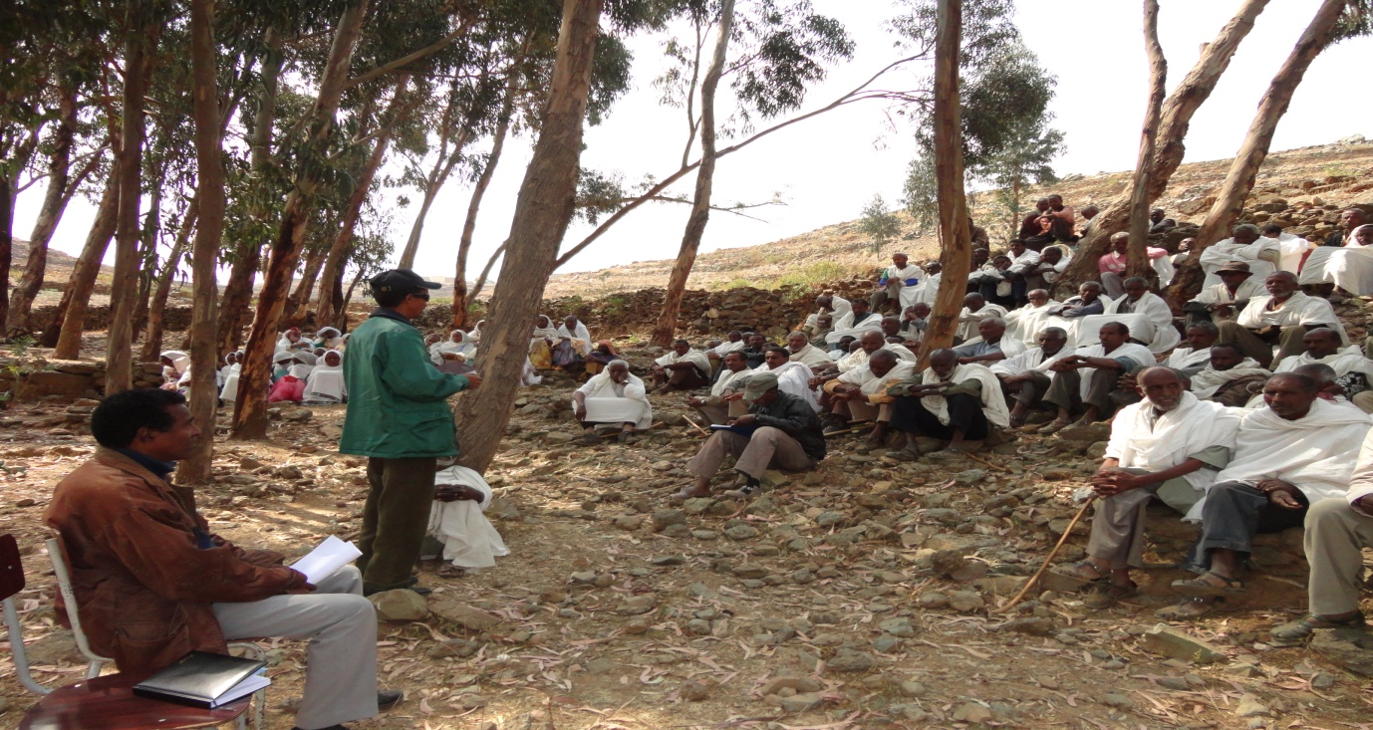

3. Establishment and training of village committee
Committee elected in five selected villages. The committee members are ranging from 5 to 7 from each village. The committee comprises Akuaro (Registrart), Gelafo (Verifiers), and Metaro (Land distributor)
S.No | Village | No of members
1 | Guritat | 9
2 | Hayelo | 9
3 | Weki | 9
4 | Dekseb | 9
5 | Embaderho | 15

One week training was given to all elected committee members, MoA and subzone serejeka staff members.
The content of the training was:
- Land proclamation (land proclamation 94/58)
- Introduction to SLM and overall activities
- Procedures of implementing agricultural usufruct
S.No | Village | No of participants
1 | Guritat | 9
2 | Hayelo | 9
3 | Weki | 9
4 | Dekseb | 9
5 | Embaderho | 15
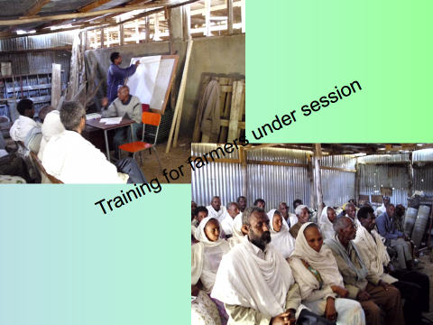
4. Verification of land classification and testing implementation procedure in each village.
In each village experts from DoL, MoA and elected village committee members verify land classification maps on ground and test implementation procedures of land allocation.
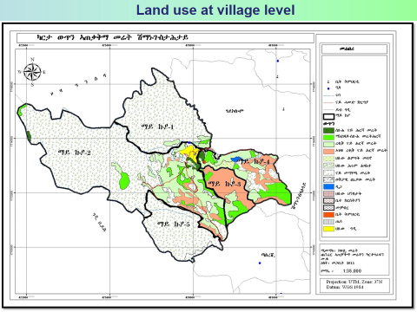

4. Preparation of agricultural usufruct guidelines
Detail usufruct guidelines has been prepared by DoL and enriched with inputs from MoA staff, local administration members and the public.
5. Preparation of forms and certificates
Application forms and usufruct right certificates has been developed and printed.
6. Reforestation activity
- In all the 28 villages 90 ha. Of land terraced and planted with 289,521 different tree seedlings. The survival rate is over 94%. The seedlings produced by ministry of agriculture and the labour is community contribution.

- 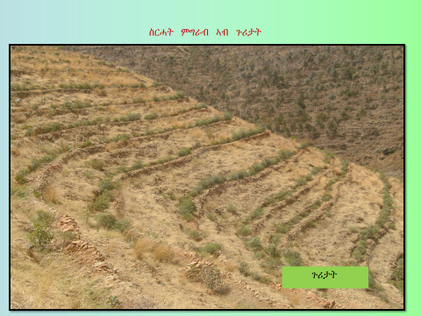
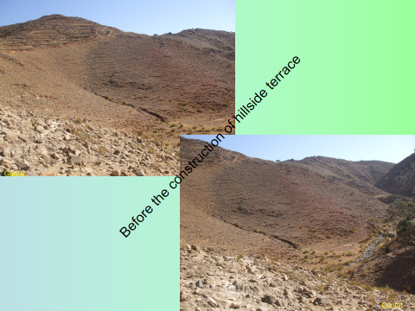

7. Registration of farmers
In this Quarter the main activities were registering applicants in the selected villages and preparing for the actual classification of parcels to be distributed to the farmers.
Based on his application and registration forms have been printed and distributed to each village. Moreover, training was given to local admiration bodies, village elders, and Ministry of Agriculture extension staff on how to fill the application forms. At this time almost all the selected villages except Embaderho, have already completed registration of applicants.Embaderho village was in the process of establishing new admiration body, now they have started the registration process and will be completed by the end of November 2014.The number of applicants registered is given in the table given.
S.No | Village | No of applicants
1 | Weki | 419**
2 | Guritat | 266
3 | Dekseb | 181
4 | Hayelo | 71
5 | embaderho | 800
Total |  | 1737

** Some more applicants are expected in Weki and Embadeho as the expected number of applicants is around 600 and 1500 registration process is extended for further one week.
The monitoring and evaluation division of the department of Land is in the process of processing these applications, and handle it in data base.

8. Classification of parcels
The procedure for classifying the agricultural land to parcels for individual farmers has been developed and approved by the department of land .The land use and cartography has made the necessary preparation to implement it on the ground and the necessary training is already given to the participating staff members. The actual implementation started in all the 5 villages and up to now 1200 individual plots of 0.5,-0.7 ha of land parceled and it is expected that each farmer will know his plot of land before the end of the year.
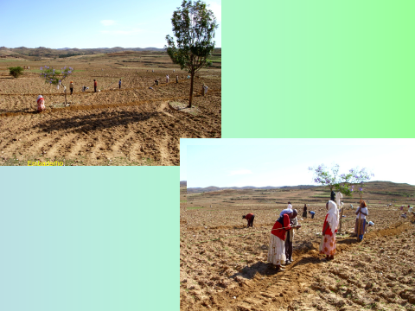

9. Procurement

- 1,000 spades and 1,000 pickaxes6000sickls procured to be distributed to selected farmers in each target villages.
- 4metres (50m) and 2adapters purchased to facilitate parcelation.
These tools will be distributed to farmers who might be allocated to relatively marginal agricultural land after allocation as part of the incentive package to help farmers to develop their farm land better.
10. Socio economic and land degradation base line study
The overall objective of this assignment is to deliver comprehensive information set including a baseline report on socio-economic and land degradation that provides relevant and clear data against which project effectiveness and impact can be monitored and measured. Baseline study in general would look at the environmental and economic conditions of the project area that should serve as a reference for the short term and longtime effects.
The specific objectives of the baseline study are to:
- Provide data on the current land degradation and socio-economic situation of the project site and targeted communities, in line with the indicators identified in the project M&E framework;
- Undertake analysis data to assist in confirming target groups and beneficiaries and validate and review M&E indicators as required;
- Provide clear and relevant baseline data as part of a longitudinal study, by Provide clear and relevant baseline data as part of a longitudinal study, by which project progress, effectiveness, quality and impact can be analyses and measured;
- Provide information that will guide the revision of activities and implementation;
- Provide data that is comparable to other projects.

Scope of work
The assessment work will comprise of two components as indicated here below:
- Land degradation baseline survey;
- Socio-economic assessment;

Current progress of Achievement
- Terms of reference (TOR) prepared and tendered
- Contract document prepared, and signed by two parties, and work is in progress by the consultant.
11. Conclusion
The project has got noble idea to address the land degradation induced low productivity of agriculture by following holistic approach of involving all the stake holders centering the community .In the last years with the frame work of the project tangible and quite remarkable activities have been carried out. Some of them are:
-Land capability and use planning at project and village level
-Reforestation, soil and water conservation (over1million tress from embaderho to guritat)
-Training of farmers and staff
-Organizing SLM implementing committees from zoba to village to promote mainstreaming SLM.
-Introduction of energy saving stoves (mogos),etc
The main actors were, the community, administration from zoba Maekel village, ministry of agriculture, ministry of land water and environment and UNDP country office.
Despite these achievements the project did not perform according to the designed work plan up to now, mainly due to continues interruptions and, delay of financial flow.

IV. FUTURE WORK PLAN

Plan for next quarter
The following are some of the core activities for the next quarter:
- To finalize agricultural land distribution to all the remaining 23 villages.
- Finalize the socio economic and land degradation base line study.
- Conduct mid-term and final review
- Purchase (6000sickles,10,000chicks,materials, and other equipment)
- Finalize the role and specific activities of Hamelmalo Agicicultural collage (HAC), and National Agricultural research institute (NARI) after land distribution.

Annual Work Plan 2014
Country: Eritrea
SPCF Outcome: Eritrea is on track towards the achievement of MDG targets for environmental sustainability (MDG7)
Expected Outcome (SRF): Support development and protection of the environment and natural resources.
Expected Outcome Indicator: Number of households with improved land use management system and level of increased production
Expected Outputs: Enabling conditions for sustainable land management established

Coordinating Authority: Ministry of National Development

Implementing partners: Ministry of Land, Water and Environment
The proposed project will provide an enabling environment for sustainable land management through four outcomes that overcome the barriers, and are in line with the objectives of the GEF Strategic Investment Program for SLM in Sub-Saharan Africa (SIP) and SPCF 2013-16. These include i) development and testing of SLM models in pilot areas; the Serejeka sub-zoba of the Maekel Zoba, one of Eritrea’s major regions. A significant part of the model will be the testing of application of the 1994 Land Proclamation provisions, as an incentive to SLM; ii) support to the establishment of sustainable knowledge management systems to provide quality and timely information for decision making, help disseminate lessons; iii) establish a critical mass of skilled and empowered SLM actors in Eritrea; and iv). establish a natural resource management monitoring systems by which lessons and experience of Eritrea are shared widely.

Estimated annualized budget: 112,000.00

Allocated resources: _______
- Government _______
- Regular (UNDP) 69,000.00
- Other:
-Donor (GEF) 112,000.00
-Donor _________
-Donor _________
Unfunded budget: _______

Programme period: 2013 - 2016
Programme Component: Environment and Sustainable development.
Project Title: Sustainable Land Management Pilot Project
Project Code: 00063220
Project Duration: 2013- 2015

Agreed by Government Coordinating Body (MND):
________________________________________________________________________________

Agreed by Implementing Partner: (Zoba Maekel Adminstrative Region)
________________________________________________________________________________

Agreed by UNDP:
________________________________________________________________________________

V. FINANCIAL IMPLEMENTATION

TOTAL APPROVED BUDGET

GEF: 1,820,000.00 USD
NORAD: 1,000,000.00 USD
UNDP: 1,000,000.00 USD

TOTAL: 3,820,000.00

TOTAL 2014 BUDGET

USD: 181,000.00

EXPENDITURE 2014

USD: 164,000.00
http://resourcemobili
Output 2.1: Knowledge management (KM) network formed of institutions and projects concerned with  Output 2.2: Capacity for research on SLM supported;  Output 2.4: SLM is mainstreamed into relevant programmes, policies & legislation, & is integrated throughout development planning & budgeting processes.  Output 3.1 Training programmes on SLM for different groups (farmers, land managers, technical officers) available and training conducted (with a focus on pilot site).  Output 3.2: Extension package updated with SLM best practice provided and other relevant materials developed through KCAS successfully delivered to key target groups and intended impacts on awareness and skills base achieved.  .  Output 3.4: SLM actions are climate change proof, mainstreaming adaptation and mitigation  Output 4.1: Effective project management and implementation structures are established and function  Output 4.2: Project M&E system established, adaptive planning takes place and project performance on track  Project Management | 2.1.3 Establish relevant delivery mechanism and implement KCAS i.e. in a form of a SLM information management systems at the level of the Zoba Maekel, with access beyond; M&E of implementation  2.2.5 Facilitate availability of research information and research collaboration including with international Centres of Excellence/research institutions (e.g. research traineeships, exchange visits, internet based information portal)  2.4.2: Implement targeted capacity support and awareness programme in CHZ with the aim to facilitate that SLM is better integrated into annual programs and budgets at zoba and sub-zoba levels  3.2.2 In support of output 2.4 develop material targeted to senior decision-makers; implement pilot site visits to community to establish a direct exchange and debate on SLM between the farmers and senior policy and decision-makers  4.2.2: Confirm M&E plan at inception meeting; follow-up regularly.  4.2.3: Implement M&E schedule as agreed to in project document.  5.2: Audit  5.3: Equipment for Land Distribution |  | X | X | X |  |  |  | 10,000.00  10,000.00  15,000.00  5,000.00  10,000.00  25,000.00  3,000.00  20,000.00
  2.2.2 Develop local level research capacity through implementing Farmers’ Action Research programme addressing key SLM needs at pilot sites, including local level resource tracking/ monitoring/ SLM M&E activities leading to adaptive management
  2.2.3Train extension personnel from both government and non-government sectors in research extension skills and targeted SLM related research skills
  2.2.4 Develop a SLM trainee programme/course for (agricultural) colleges and, if appropriate, University
      - Implement CSSAP during project duration and, through a long-term mainstreaming strategy, ensure that activities are integrated into institutional programmes and continue beyond project horizon
      - Develop and implement a strategy for adapting SLM to climate change in Eritrea, linked to NAPA and related CCA projects
  4.1.5: Adaptively manage project implementation, link to output 4.2
 | Total USD 1,486,000.00

zation.brsp.undp.org/files/Standard_Progress_Report.doc

